THIS IS A PRACTICE ASSESSMENT. Show formulas, substitutions, answers, and units!
Topic 4.1 – Oscillations
A mass is attached to a horizontal spring. If displaced from equilibrium and released, the mass takes 0.25 seconds to return to its original position.
1. The mass is pulled 4.0 cm in the positive x-direction before release, as shown. What are the amplitude, period, and frequency of the oscillation?

2. An identical system is started by pushing the mass 4.0 cm in the negative x-direction. It is released at the same instant the mass in problem 1 is released. What is the phase difference between the two systems?

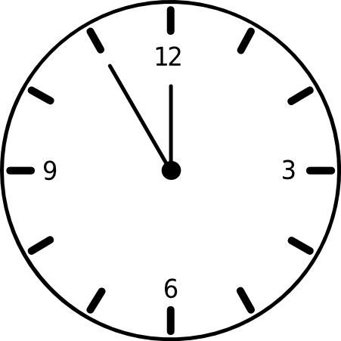
The following questions are about a clock. The radius of the minute hand on the clock is 7.0 cm.
3. What are the period and the frequency of the minute hand?

4. What is the speed (in cm s⁻¹) of the tip of the minute hand?

A 4.00-kg mass is shown in the mass/spring system at its starting release point. The spring constant of the spring is 0.250 Nm⁻¹. The grid is marked off in 1.00 cm intervals.
5. In the picture place a “V” at all the points where the speed of the mass will be at its maximum.

6. In the picture place an “A” at all the points where the acceleration of the mass will be at its maximum.

7. What is the proportionality constant for this particular system that relates a to –x in the proportion a ∝ -x that defines SHM?

8. What is the acceleration (in cm s⁻²) of the mass at x = - 2.00 cm?

9. What is the acceleration (in cm s⁻²) of the mass at x = + 1.00 cm?

10. What is the force (in N) acting on the mass at x = + 1.00 cm?

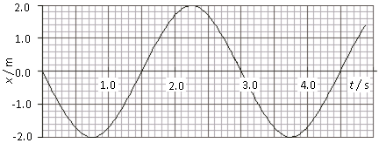
The displacement vs. time of a 2.5-kg mass attached to a spring having a spring constant of 0.125 Nm⁻¹ undergoing SHM is shown in the graph.
11. What is the amplitude of its motion?
12. What is the total energy of the system?

13. What is position of the mass at t = 2.75 s?

14. What is the potential energy stored in the system at t = 2.75 s?

15. What is velocity of the mass at t = 2.75 s?

16. What is acceleration of the mass at t = 2.75 s?

17. In the graph above, sketch in the velocity of the mass vs. time, and label it “V.”

18. In the graph above, sketch in the acceleration vs. time and label it “A.”

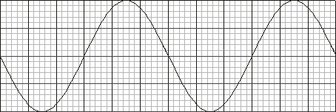
The displacement vs. time of a particle undergoing SHM is shown in the graph to the right.
19. In the graph, sketch in the displacement vs. time for in-phase SHM with exactly half the amplitude of the given SHM.

20. In the graph above, sketch in the displacement vs. time for SHM that is exactly T/ 6 out of phase.

21. How many degrees is this phase angle? How many radians?

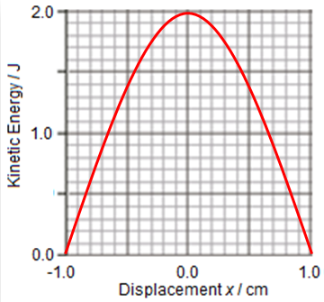
The kinetic energy vs. displacement of a 1.25-kg particle undergoing SHM on a mass-spring system is shown in the graph to the right.
22. What is the maximum speed of the mass?

23. What is the maximum potential energy stored in the mass-spring system?

24. What is the spring constant of the spring that is driving the oscillation?

25. In the graph, sketch in the potential energy vs. displacement of the oscillating system.

26. At x = 0.65 cm, what is the potential energy stored in the system?

27. At x = 0.65 cm, what is the kinetic energy of the mass? What is its speed?

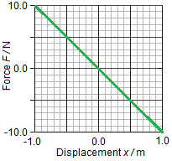
In the graph to the right, the spring force vs. displacement is shown for the spring in an oscillating mass-spring system. The mass is 0.25 kg and the amplitude of motion is 1.0 m.
28. What is the value of the spring constant?

29. What is the total energy of the system.

30. How can you tell that the oscillation is that of SHM?

31. What is the maximum speed of the mass?

32. What is the acceleration of the mass when it is traveling at its maximum speed?

33. What is the maximum acceleration of the mass?

34. What is the speed of the mass when the displacement is x = -0.50 m?

Topic 4.2 – Traveling waves
35. What is the difference between a transverse and a longitudinal traveling wave?

36. Explain what compressions and rarefactions are, and what type of traveling wave has these characteristics.

37. Explain what wavefronts and rays are, in terms of longitudinal waves.

38. Explain what crests and troughs are, and what kind of traveling wave has these characteristics.

39. What kind of oscillation are the particles of a medium carrying a traveling wave undergoing?

40. Explain how you could make a traveling wave appear to move through a set of identical hanging mass-spring systems all lined up in a row. Make a sketch to illustrate and clarify your explanation. Be sure to talk about amplitude, phase and period.

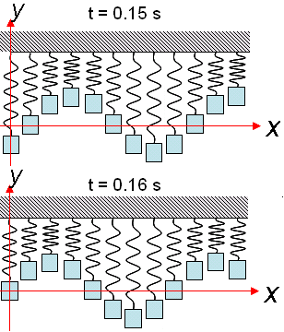
Twelve identical mass-spring combos are lined up and set to oscillation. Two pictures of the same system taken at different times are shown to the right. The crest-to-crest distance is 8.0 cm, and the maximum displacement of all of the masses is 1.5 cm.
41. Explain how you can tell that a traveling wave is present.

42. Which direction is the wave traveling? Be sure to justify your response with a reasoned explanation.

43. Make an estimate of the period of the oscillation of each mass.

44. What is the frequency of the traveling wave?
45. What are the amplitude and the wavelength of the traveling wave?

46. What is the wave speed?


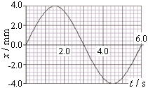
Consider the wave train being transmitted through the spring as shown. The accompanying graph shoes the motion of a single loop of the spring as it moves back and forth in SHM.
CM
2
1
3
5
4
6
7
8

47. In the picture place a C at each center of a compression. In the picture place an R at each center of a rarefaction.

48. What is the frequency of the wave train?

49. What is the wavelength (in cm) of the wave train?

50. What is the wave speed (in cm s⁻¹)?

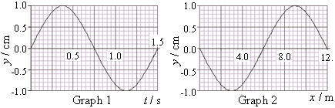
A traveling wave has displacement y vs. time shown in Graph 1 and displacement y vs. horizontal position x in Graph 2.
51. What are the amplitude and the period of the traveling wave?

52. What are the wavelength and the wave speed of the traveling wave?

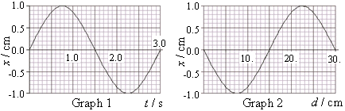
A longitudinal wave has displacement x vs. time shown for a single particle in Graph 1 and displacement x vs. horizontal position d for a particular instant in Graph 2. Graph 3 shows 5 particles in the longitudinal wave at their equilibrium position.
53. For each of the 5 particles, in Graph 3 (below) place an × reflecting the particles’ positions at the instant depicted in Graph 2.
d / cm
0.00
10.
20.
30.
Graph 3

54. In Graph 3 place an R at the center of a rarefaction. At what d value or values in Graph 3 do you predict there is a center of a compression?

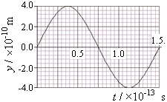
The displacement y vs. time t graph of a light wave is shown.
55. Find the frequency of the light. What portion of the electromagnetic spectrum does this place this light?

56. Find the wavelength of the light.

57. Explain why you don’t need a displacement vs. distance graph for light, but you do for other traveling waves?

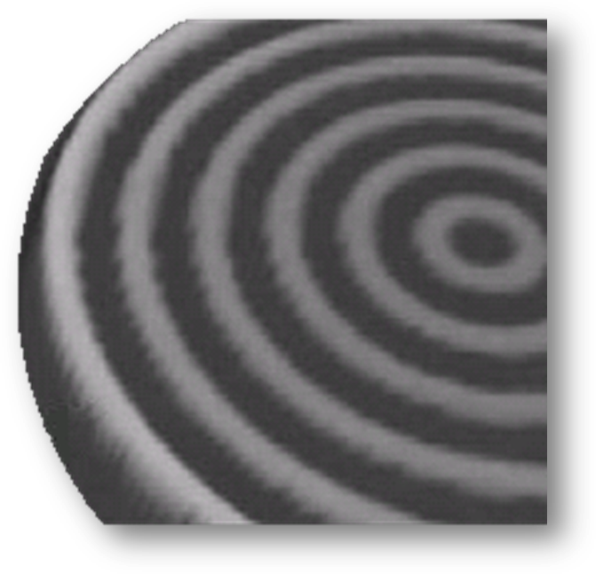
Topic 4.3 – Wave characteristics
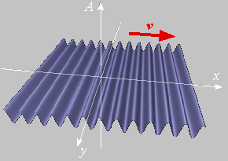
58. Sketch the wavefronts in each picture. In the circular waves sketch in the wave rays. What type of waves are these all examples of?
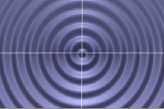

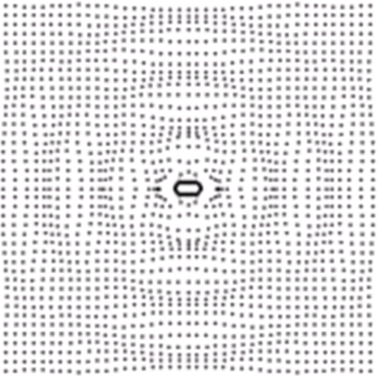
59. Sketch the wavefronts and rays. What type of wave is illustrated?


60. A 675 watt speaker projects sound in a spherical wave. Find the intensity of the sound at a distance of 2.0 m and 8.0 m from the speaker.

At a distance of 27.5 m from a sound source the intensity is 4.25×10 ⁻¹ W m⁻².
61. Find its intensity at a distance of 15.5 m.

62. Compare the amplitudes of the sound at 27.5 m and 15.5 m.

A traveling wave having a wave speed of 325 m s⁻¹ strikes a boundary between two mediums with an angle of incidence of 25°. Some of the wave’s energy is reflected at the boundary, and some of it is transmitted through the boundary and into the second medium, where its speed is reduced to 245 m s⁻¹.
63. Sketch the normal, and the angle of incidence in the diagram.

64. Find the angle of reflection and sketch the reflected ray.

65. Sketch the refracted ray.


A traveling wave whose wavefronts are shown strikes a boundary between two mediums as shown. The frequency of the incident wave is 50 Hz, and the wavelength is 0.85 m. The angle of incidence is 23° and the angle of refraction is 26°.
66. Sketch the wavefronts of the refracted wave.

67. How does the frequency of the refracted wave compare to that of the incident wave?

68. How does the wavelength of the refracted wave compare to that of the incident wave?

69. How does the wave speed of the refracted wave compare to that of the incident wave?

70. A wave pulse is approaches a fixed point in a string. Sketch in the pulse shape after reflection.

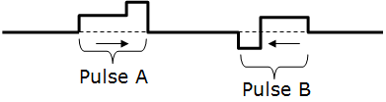
71. Two wave pulses approach each other from opposite directions as shown. Sketch the waveform when the trailing edge of Pulse A and the leading edge of Pulse B are coincident.

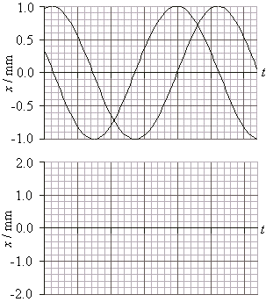
Two traveling waves reach a point in the medium at the same time and act simultaneously on it. The top graph shows the two waves.
72. In the bottom graph make an accurate sketch of the point’s displacement vs. time as a result of the two waves. The time axes are the same.

The following questions are about polarization and polarized light.
73. Describe what is meant by polarized light.

74. Describe polarization by reflection.

75. State Brewster’s law.

76. Unpolarized light in air is reflected from a liquid surface in such a way that it is completely polarized. The angle of incidence is 48°. What is the angle of refraction in the liquid?

77. Explain the terms polarizer and analyzer.

78. Two disks of Polaroid are aligned so that they polarize light in the same plane. Calculate the angle through which one sheet needs to be turned in order to reduce the amplitude of the observed E-field to one-third of its original value.

79. If the initial intensity was I₀, what will the new intensity be (at the angle you just calculated)?

80. If we want the intensity to be one-third of its original value, what must be the angle through which one of the sheets is turned.

81. Describe what is meant by an optically active substance.

82. Describe the use of polarization in the determination of the concentration of certain solutions.

83. Outline qualitatively how polarization may be used in stress analysis.

84. Polarized light of intensity I₀ is incident on an analyzer. The transmission axis of the analyzer makes an angle θ with the direction of the electric field of the light waves entering it. Sketch a graph to show the variation of the intensity of the light transmitted through the analyzer as θ changes from 0° to 270°.

85. A ray of plane-polarized light of intensity 8.5 Wm⁻² is normally incident on a polarizing filter. The intensity of the transmitted light is 5.6 Wm⁻². Calculate the angle between the plane of the polarized light and the preferred plane of the filter.

Topic 4.4 – Wave behavior
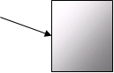
A light wave traveling in air strikes a piece of glass as shown. The frequency of the incident wave is 5.1×10¹⁴ Hz. The angle of incidence is 28° and the angle of refraction is 22°.
86. Find the speed of light in the glass.

87. Find the index of refraction of the glass.

88. Find the wavelength of the incident light wave.

89. Find the frequency and wavelength of the refracted light wave.

90. Sketch the wavefronts for both the incident and reflected light.

91. What is the critical angle of the light once it is inside the glass?

92. What is the critical angle of the light once it is inside the glass if the glass is submerged in water?


The incident wave train pictured in the lower half of the photograph has an amplitude of 7 cm. Assume the wave energy is not lost in passing through the two gaps in the barrier wall. The lightest-colored portions in the upper half of the photograph are the highest regions of water. The darkest-colored portions are the lowest regions of water. For the following questions, heights are to be referenced to equilibrium, which is 0 cm.
93. State Huygens’ principle.

94. What will be the height of the lightest-colored portions of the waves in the upper half of the photograph?

95. What will be the height of the darkest-colored portions of the waves in the upper half of the photograph?

96. Place a small circle at a single point of your choosing that shows constructive interference.

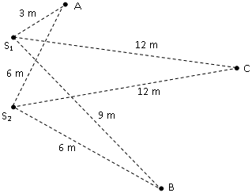
The following questions concern path difference in waves.
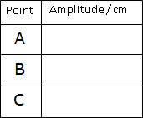
97. Two sources S₁ and S₂ each produce coherent vibrations in water having a wavelength of 6 m and an amplitude of 10 cm. Three surrounding points are shown. The lines connecting the sources to the points show the distance the points are from the sources. Complete the table:

98. What does the term coherent mean in the context of waves?

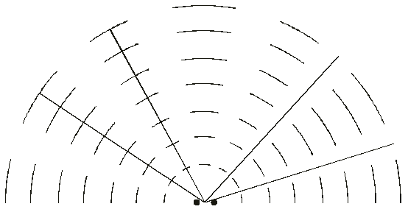
The interference patterns caused by two coherent wave sources are shown to the right. Four reference lines are shown in the medium representing constructive and destructive interference.
99. Label the lines representing path differences of PD = 1λ, PD = 2λ, PD = 1.5λ, and PD = 2.5λ.

The following questions are about Young’s double-slit diffraction.
100. Coherent light having a wavelength of 975 nm is incident on an opaque card having two vertical slits separated by 0.250 mm. A screen is located 5.25 m away from the card. What is the distance between the central maximum and the first maximum?

101. Coherent light of an unknown frequency is projected onto a double-slit with slit separation 0.125 mm onto a screen that is 12.6 meters away. The separation between the central maximum and the nearest maximum is 1.20 cm. What is the frequency of the incident light?

The following questions are about wave behavior.
102. What behavior of waves causes the straight waves to become curved waves when they pass through the gaps in the barrier?

103. What behavior of waves causes the curved waves to produce the highs and lows previously calculated?
Topic 4.5 – Standing waves
The following questions are about the creation of standing waves.
104. What does it mean for two waves to be coherent?

105. How are standing waves created? Why are they called standing waves?

106. What are nodes and antinodes in the context of standing waves?

The following questions are about a string fixed at both ends.
107. Sketch the 3rd harmonic standing wave in the string.

108. If the speed of sound in the string is 1100 m s⁻¹ and length of the string is 16 m, what is the frequency of the third harmonic of the string?

109. What is the fundamental frequency of this string?

The following questions are about a pipe closed at one end.

110. Sketch the 3rd harmonic standing wave in this pipe:

111. If the speed of sound in air is 340 m s⁻¹ and the length of the pipe is 16 m, what is the fundamental frequency of the pipe?


The following questions are about a pipe open at both ends.

112. Sketch the 3rd harmonic standing wave in this pipe:

113. If the speed of sound in air is 340 m s⁻¹ and the length of the pipe is 16 m, what is the fundamental frequency of the pipe?

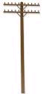
The following questions are about a telephone pole having standing waves generated in its length by prevailing winds.
114. If the length of the pole exposed above the ground is 25 m, what is its fundamental frequency? The speed of sound through the pole is 75 ms⁻¹.

115. What is its third harmonic?

116. Explain how an oscillating telephone pole is similar to an oscillating tuning fork.

