THIS IS A PRACTICE ASSESSMENT. Show formulas, substitutions, answers, and units!
Topic 10.1 – Describing fields
The first 19 questions of this Problem Set are about projectile motion near Earth’s surface, where the gravitational field strength is g = 10 ms⁻². They serve as a review of this important Topic 2 material.
1. How are the vertical and horizontal components of velocity for a projectile in a uniform field related?

2. Sketch the trajectory of a projectile in the absence of air.

3. Sketch the trajectory of a projectile when there is air resistance. What can you say about the peak? What can you say about the pre-peak and post-peak distances?

4. List the reduced kinematic equations for projectile motion in the absence of air.

5. Use the reduced equations above to prove that projectile motion (in the absence of air resistance) is parabolic.

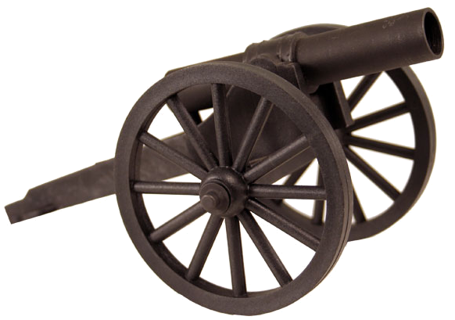
A cannon fires a projectile with a muzzle velocity of 175 ms⁻¹ at an angle of inclination of 30°.
6. What are u_{x} and u_{y}?

7. What are the tailored equations of motion for the projectile. Assume there is no air resistance.

8. When will the ball reach its maximum height?

9. How far from the muzzle will the ball be when it reaches the height of the muzzle at the end of its trajectory?

10. For the same cannon sketch the following graphs: a vs. t, v_{x} vs. t, and v_{y} vs. t:

11. For the same cannon sketch the following graphs: x vs. t, and y vs. t:



A ball is thrown horizontally off of the Cliffs of Moher having a height of 214 m above the ocean at a speed of 75 ms⁻¹.
12. How long is it in the air?

13. For the same ball determine how far from the base of the cliff it strikes the ocean.

14. For the same ball determine the velocity at which it strikes the water (including magnitude and direction).

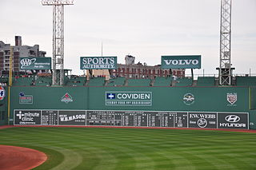
The Green Monster of Fenway Park in Boston is an 11.33 m tall left field wall that is located 94.8 m from home plate. A batter hits a low baseball ball at an angle of inclination of 30° with a speed of 38 ms⁻¹.
15. By what distance will the ball clear the wall? Assume there is no air resistance.

16. What maximum height will the ball reach during its flight?

17. What is its speed when it is at its maximum height?

The following questions are about conservative forces.
18. What is a conservative force or field? Name three conservative forces.

19. What class of forces has associated potential energy functions?

A
B
30°
12.5 m
20. A 25.0-kg box is pushed horizontally from A to B on a floor along the two paths shown. The coefficient of dynamic friction between the box and the floor is 0.225. Find the work done by friction over each of the two paths (use g = 9.83 ms⁻²). Then state whether or not friction is a conservative force, and justify your statement.

The following questions are about fields.
21. Why is the field view preferable to the action-at-a-distance view of forces?

22. Explain how the field view differs from the action-at-a-distance view of force.

23. Why are test masses and charges extremely small?

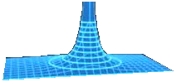
The following questions are about the set of equipotential surfaces shown to the right.
24. A student claims that the surface shown to the right could be the set of equipotentials surrounding a mass or a charge. Another student claims it can only be associated with a charge. Which student is correct, and why?

25. Sketch in the field lines in the figure. Be sure to include directional arrows.

26. A negative charge is placed on the third ring from the bottom and released. What motion will it seek to follow?

27. A positive charge is placed at the same position and released. What motion will it seek to follow?

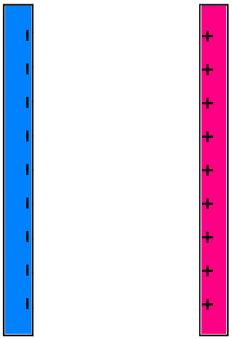
The following questions are about the parallel, oppositely-charged plates shown to the right.
28. Sketch in the electric field lines, both between the plates and at the edges.

29. Justify that the electric field strength is constant between the plates by refering to your sketch.

30. Sketch in five equipotential surfaces (besides the two plates). If the potential difference between the two plates is 21 V, what is the potential difference between each adjacent pair of surfaces you sketched?

The following questions are about gravitational potential and the gravitational field.
31. Define gravitational potential difference

32. Sketch the pattern of gravitational field lines and equipotential surfaces surrounding a point mass.

33. Sketch the pattern of gravitational field lines and equipotential surfaces surrounding two point masses.

34. Explain why there is not a gravitational dipole.

35. State the geometric relation between equipotential surfaces and gravitational field lines. Are your previous two sketches correct?

36. Use the definition of work (W = Fd cos θ) and the definition of gravitational potential difference (ΔV_{g} = W/m) to show that the gravitational field strength near the surface of Earth is g = -ΔV_{g} /Δh.

37. A 3.25-kg mass is moved from a point A in space having a gravitational potential of 0.0350 J kg⁻¹ to a point B in space having a gravitational potential of 0.0215 J kg⁻¹. How much work was done by the gravitational force during that displacement? Does it matter what path the mass followed in going from A to B? Why?

A charge of q = -25.0 μC is moved from point A, having a voltage (potential) of 17.5 V to point B, having a voltage (potential) of 12.0 V.
38. What is the potential difference undergone by the charge?

39. What is the work done in moving the charge from A to B?

40. Why did the system gain energy during this movement?

The following questions are about electrostatic potential and the electric field.
41. Define electrostatic potential difference.

42. Sketch the equipotential surfaces surrounding a negative charge.

43. Sketch the equipotential surfaces surrounding a positive charge.

44. Sketch the equipotential surfaces surrounding a dipole charge.

45. Sketch the equipotential surfaces surrounding two negative charges.

46. Sketch the electric field lines in each of your previous sketches. What is the geometric relationship between the E-field lines and the equipotentials?

The following question is about the electric field strength between two oppositely-charged parallel plates.
47. Use the definition of work (W = Fd cos θ) and the definition of electrostatic potential difference (ΔV_{e} = W/q) to show that the electric field strength between two oppositely-charged parallel plates separated by a distance d is E = -ΔV_{e} /d. Hint: Recall that F = qE from Topic 5.

The following questions are about electric field strength and equipotential surfaces. A conductor is surrounded by equipotential surfaces changing by equal voltage increments, as shown. The shaded region is a positively-charged conductor.
A
C
B
D
48. Choose the best answer. Which point has the largest electric field strength?

49. Sketch the electric field lines surrounding the conductor.

The following questions are about a positive charge and a flat conductor.
+
50. Draw the electric field lines between the positive charge and the flat conductor.

51. Now sketch in the equipotential surfaces between the charge and the conductor.

Topic 10.2 – Fields at work
The following questions are about gravitational potential energy, potential, and potential gradient.
52. Define gravitational potential energy.

53. State the expression for gravitational potential due to a point mass.

54. Find the change in gravitational potential in moving from Earth’s surface to 2 Earth radii (from Earth’s center).

55. State the expression relating gravitational field strength to gravitational potential gradient.

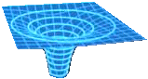
56. The gravitational potential in the vicinity of a planet changes from -2.85×10⁷ J kg⁻¹ to -2.79×10⁷ J kg⁻¹ in moving from r = 2.80×10⁸ m to r = 2.85×10⁸ m. What is the gravitational field strength in that region?
P

57. An equipotential surface caused by a mass is shown. Find the value of the gravitational field strength at the point P. The vertical axis is in increments of 4.00 ×10⁶ J kg⁻¹ and the grid lines in the x and y directions are in increments of 1.00×10⁶ m.

Four point masses, each of which has a mass of 250 kg, are arranged in a circle of radius 1750 m as shown.
58. What is the gravitational potential at the center of the configuration?

59. What is the gravitational potential at the midpoint of the line joining the center of the moon to the center of the earth? Consider only the potential due to the earth and the moon only.

The following questions are about escape speed and orbital speed.
60. Explain the concept of escape speed from a planet.

61. Derive an expression for the escape speed of an object from the surface of a planet.

62. What is the escape speed from Earth (mass = 5.98×10²⁴ kg, radius r = 6.37×10⁶ m)?

63. What is the escape speed from the moon (mass = 7.36×10²² kg, radius r = 1.74×10⁶ m)?

64. What is the orbital speed about Earth at one Earth radius altitude?

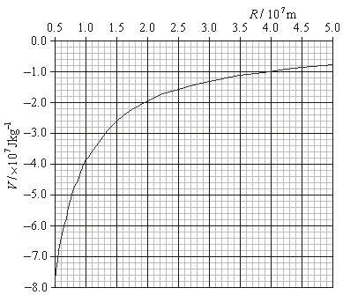
The graph shows the variation with distance from center of the gravitational potential due to a planet whose radius is 0.5×10⁷ m.
65. From the graph find the gravitational field strength at the surface of the planet.

66. Calculate the mass of the planet.

67. What is the escape speed from this planet?

68. A satellite having a mass of 4.6×10³ kg is launched from the surface of the planet to a height of 3.0×10⁷ m (above the surface). Use the graph to estimate the minimum launch speed needed to get the satellite to that height. Assume that it reaches its maximum speed immediately at launch and that the satellite comes back down.

69. What force provides the centripetal acceleration of a satellite in orbit?

70. What minimum speed would be necessary to actually get the satellite in orbit about the planet at the specified height?

The following questions are about a spacecraft of mass m in orbit about about a planet of mass M.
71. Starting with E_{K} = (1/2)mv² show that in terms of orbital radius the kinetic energy of the spacecraft is E_{K} = GMm / (2r).

72. Using your expression from the previous problem, the expression for potential energy, and the conservation of mechanical energy, show that the total mechanical energy E of the spacecraft in orbit at a radius r is given by E = -GMm/(2r).

73. Sketch graphs showing the variation with orbital radius of the kinetic energy, gravitational potential energy and total energy of the spacecraft. Be sure to include all graphs on a single energy vs. radius coordinate system.
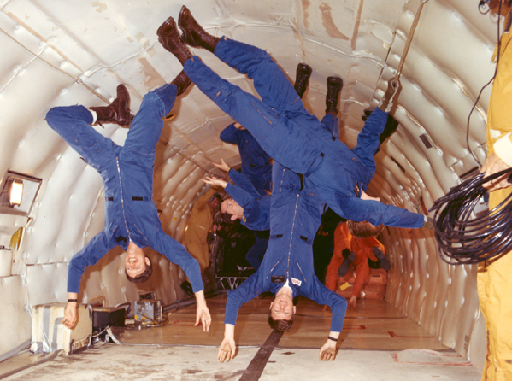
74. Discuss the concept of weightlessness in orbital motion, in freefall and in deep space.

The following questions have to do with Kepler’s 3rd law and an orbiting satellite.
75. Find the period of a satellite that is located at an altitude of 1 Earth radius above the surface.

76. Using Newton’s law of gravitation and his second law, derive Kepler’s 3rd law for circular orbits.

77. Using Kepler’s 3rd law find the period of a satellite that is two earth radii above the surface.

A geosynchronous satellite has a period of 24 h and can thus always be over the same point on the earth.
78. The following figure shows cross-sections of two generalsatellite orbits around the earth (shaded gray). Discuss whether either of the orbits is possible, and why.
Orbit A
Orbit B
Equator

79. What is a geosynchronous satellite’s height above the surface of the earth (in terms of R₀, one Earth radius)?

80. Could this satellite be directly above any point on Earth we choose to place it? Why, or why not?

The following questions are about escape speed and black holes.
81. What must the radius of a star of mass M be such that the escape velocity from the star is equal to the speed of light c? (This is the size the star has to collapse to in order to become a black hole. It is called the Schwarzschild radius).

82. Compute the Schwarzschild radius of the sun (1.99×10³⁰ kg) and the earth.

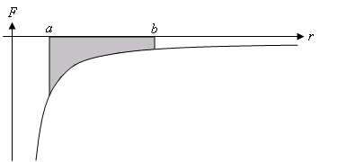
83. The graph shows the variation of the gravitational force with distance. What does the shaded region in the graph represent?

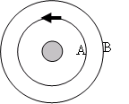
84. A satellite (represented by the arrow) is in circular orbit (A) around the earth. If the satellite is to put itself into a higher circular orbit (B) how should it orient itself before firing its engines. Assume the engines are on the tail of the arrow. Sketch in the new arrow orientation prior to engine ignition.

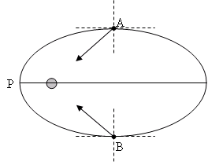
The following questions are about elliptical orbits.
85. The figure shows a planet orbiting the sun counter-clockwise, at two positions (A and B). Also shown is the gravitational force acting on the planet at each of the positions. By decomposing each force into components normal and tangential to the path of the planet (dotted lines), explain why the planet will accelerate from A to P but decelerate from P to B.

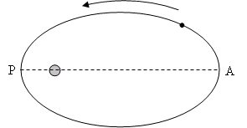
86. The figure shows a planet orbiting the sun. Explain why at points A and P of the orbit the potential energy of the planet assumes its minimum and maximum values, and determine which is which. Hence, determine at what point in the orbit the planet has the highest speed.

The following questions are about electrostatic potential energy, potential, and potential gradient.
87. Define electrostatic potential energy.

88. State the expression for electrostatic potential due to a point charge.

89. Calculate the electrostatic potential 2.5×10⁻³ m from a proton.

90. Calculate the electrostatic potential 2.5×10⁻³ m from an electron.

91. State the formula relating electric field strength to electrostatic potential gradient.

92. The electrostatic potential in the vicinity of a charge changes from -1.75 V to -1.63 V in moving from r = 1.80×10⁻³ m to r = 2.85×10⁻³ m. What is the electric field strength in that region? Is the charge (-) or is it (+)?

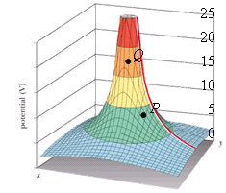
An equipotential surface caused by a charge is shown to the right.
93. Find the electric field strength at the point P. The vertical axis is measured in J C⁻¹ and the grid lines in the x and y directions are in cm.

94. Find the electric field strength at the point Q. How can you visually tell the field stronger at Q than it is at P?

95. What is the sign of the charge pictured?

The following questions are about The equipotential surfaces of a positively-charged metal sphere (shown here). Consecutive equipotential surfaces differ by 3.5 V. The surfaces are drawn to scale.
+
P
Q
R
96. Find the electric field strength (in V mm⁻¹) at the points P and Q.

97. Find the electric field strength at the point R.

Four point charges, each of which has a charge of +20 μC, are arranged in a circle of radius 5.6×10⁻³ m.
98. What is the electrostatic potential at the center of the configuration?

99. How much work is done by the electrostatic field on a proton brought from very far away to the center of the configuration?

100. If two of the charges are replaced with charges of -20 μC what will be the electrostatic potential at the center of the circle?

101. A proton and an electron are located 3.0 cm apart. What is the electrostatic potential at a point on the line joining the two charges which is 1.0 cm from the proton?

A metal sphere having a radius R₀ has a charge of -Q placed on it.
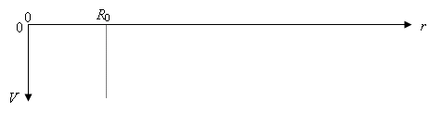
102. Sketch the electrostatic potential vs. the distance r from the center of the sphere on the graph. Include points inside and outside the sphere. Label the V axis with the value of the most negative potential.

103. If R₀ = 2.5 mm and Q = -6.25 nC, find the electrostatic potential at the surface of the sphere.

104. Find the electrostatic potential 5.0 mm from the surface of the same sphere.

A charge Q of 10.0 C is placed somewhere in space.
105. What is the work required to bring a charge of 1.0 mC from a point X, 10.0 m from Q to a point Y = 2.0 m from Q?

106. Does the answer depend on which path the charge follows?

The following questions are about an electron in an electrostatic field.
107. An electron is brought from infinity to a distance of 10.0 m from a charge of -10.0 C. How much work was done by the electrostatic field on the electron?

108. An electron moves from a point in space where the potential is 100.0 V to another point where the potential is 200.0 V. If it started from rest, what is its speed at the end of this trip?

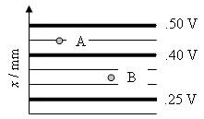
A diagram showing equipotential surfaces set up by some sort of a charge configuration is shown.
109. Find the electric field strength at the points A and B.

110. What is the force acting on an electron if placed at the point A? Which way does it point?

111. What is the force acting on a proton if placed at the point B? Which way does it point?

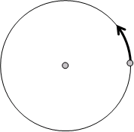
A charge -q whose mass is m moves in a circle around a stationary charge +q located at the centre of the circle, as shown.
112. Draw the force on the moving charge.

113. Show that the velocity of the charge is given by v² = kq² / (mr).

114. Show that the total energy of the charge is given by E = - kq² / (2r).

115. Hence, find out how much energy must be given to the charge if it is to orbit around the stationary charge at a new radius equal to 2r.

An electron is shot with a speed equal to 1.59×10⁶ m s⁻¹ from a point where the electrostatic potential is virtually zero toward an immovable negative charge Q as shown in the figure.
Q
P
2.0×10⁻¹⁰ m

116. What should the electrostatic potential at P be so that the electron stops momentarily at P and then turns back.

117. What is the magnitude of the charge Q that sets up this potential?

